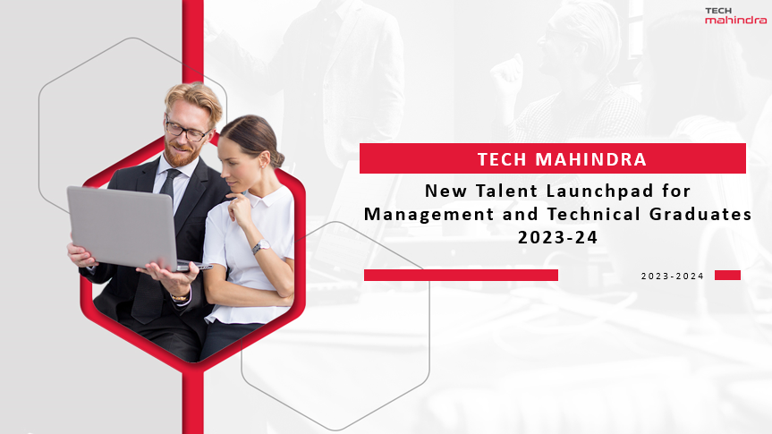

**Job Description**

**Associate Data Analyst/ Data Engineers / Data Scientists / Business Analysts**

**TECH MAHINDRA**

**Key Responsibilities: -**

* Collaborate with Senior Data Scientists / Data Engineers / Cloud & BI architects and Project Leads to design develop and test Analytical & BI solutions.
* Lead customer facing consulting activities
* Debug and troubleshoot defects and issues to ensure to ensure optimal system performance.
* Self-motivated, flexible & resourceful and should have the ability to take challenges head-on and manage deadlines
* Learn and adapt to new programming languages, frameworks, and technologies as required by projects.
* Manage projects and programs with focus on client/ stakeholder management
* Create new use cases, demos, knowledge assets/ insights for practices to demonstrate.
* Take ownership of small teams to respond to proposals, defend proposals and take part in the entire sales cycle.
* Ability to build optimized solutions for complex business problems and ability to demonstrate with wider audience.
* Take ownership of small teams to respond to proposals, defend proposals and take part in the entire sales cycle
* Efficient in writing clean, efficient, and maintainable code in accordance with industry best practices.
* Involve in strategic business planning to articulate the objectives and actions required for improved outcomes.

**Desired Skills: -**

**Professional Skills**

* Bachelor’s degree in computer science or a related field (B. Tech / BE - Computer Science, Electronics & Communication, IT, MCA)
* Master in business administration for Management trainees.
* Strong communication and presentation skills.
* Knowledge of databases and SQL.
* Excellent problem-solving skills and a passion for technology.
* Understanding of business processes.
* Hands-on experience of MS Office; especially MS Excel and PowerPoint.
* Knowledge of one of more programming knowledge in building solutions. (e.g., Java, C, C++, Python etc.).
* Ability to process raw data and fetch meaningful insights from it.
* Data-driven and a quick learner, having good analytical and Numerical skills
* Good team player who can establish a connect with all stakeholders
* Willing to work in a highly dynamic, team-oriented environment

**Preferred Skills**

* Internships, personal projects, or coursework related to software development
* Experience with version control system.
* Participation in competitions and hackathons.
* Any extra certification on Analytics, Machine Learning, Artificial Intelligence, SQL, Power BI, Databases etc.

**Soft Skills**

* Self-starter & Quick learner
* Ability to learn new technologies and process improvement techniques
* Ability to work in various time zones to support various global rollouts

**Why Tech Mahindra**

* Competitive Salary and benefits package.
* Opportunities for career growth and development, exposure to work directly with customer.
* Collaborative and innovative work environment.
* Access to cutting-edge technologies and tools.
* Focused Mentorship and training programs to enhance your skill thru best industry leaders.
* Inclusive and diverse workplace culture.
* Professional certifications for employees
* Focus on New technologies and niche skills development.